Before I start today’s sermon, I would like to commend to you a sermon that I preached at Wednesday’s 915am service. Its available on YouTube, so please do take a look when you get a moment. I have had a number of people come up to me after that sermon and I am humbled that I have been able to speak to so many. In reflecting on that sermon, I found my eye drawn to this amazing book on my shelf. (SLIDE, Book Quote) And this one passage: Take a moment to listen to the sermon and know that martin and I are here to talk or to just listen.
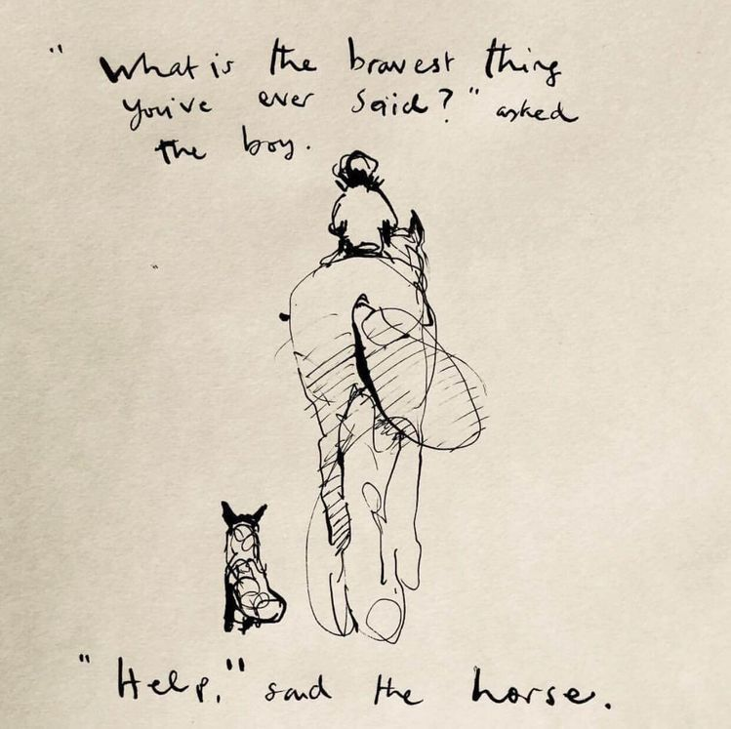

The quote from this book also spoke clearly to me when I noticed that I was preaching today.

As we join together on this Sunday, I want you to spare a thought for Curates all around the country….and probably the world, as their training incumbent hands them the challenge of preaching on Trinity Sunday! (SLIDE, ME)
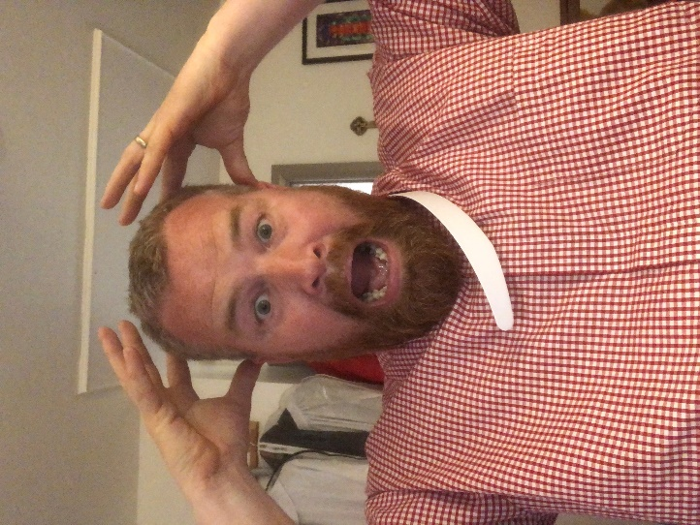
The word Heretical, which basically means you are wrong, and you need to shut up now, is hovering over the keyboard of every curate as they prepare their sermons. Do I talk about water, steam and Ice….no definitely not….what about wine and water….nope…..Let’s get the books out and see what the theologians say….These are just a few of the books I looked through in preparation for today…..and martin is brave…he doesn’t normally ask to see my sermon prep, but I thought he might today….wish me luck.
(SLIDE, Trinity)
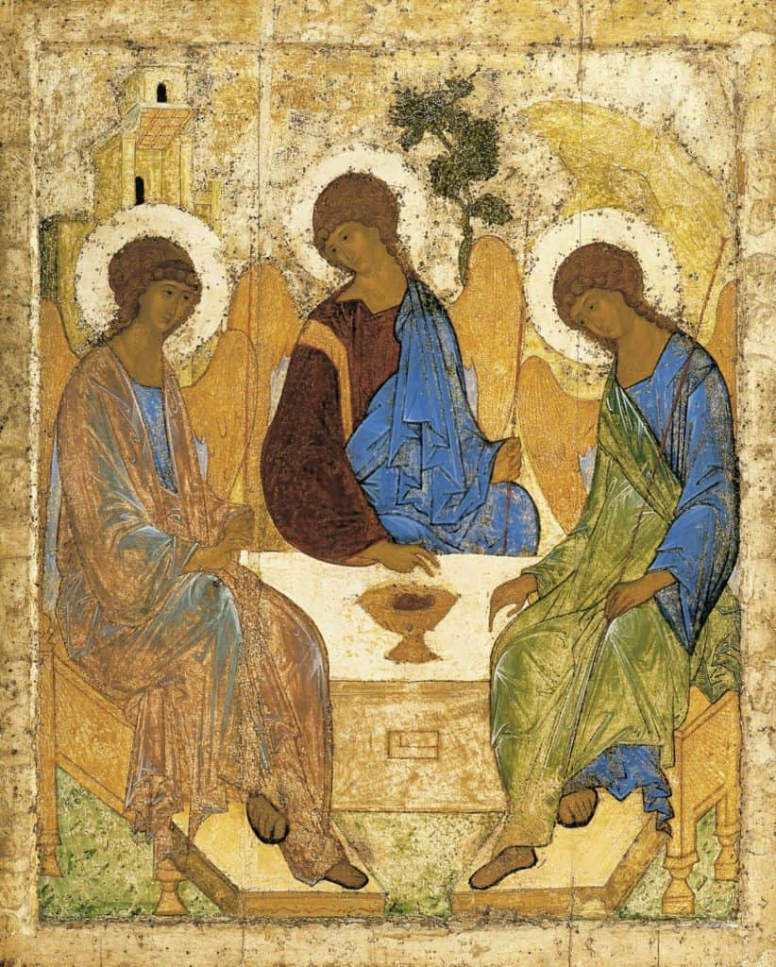
So, let’s get theological: We must get theological, as we hear Jesus tell us how important these things are….he says, more than once….’Very Truly I tell you’…..and that is our queue to listen!
A definition of the Christian doctrine of the Trinity is that there is one God, who exists in three persons, father, son and Holy Spirit. These three persons together share the one divine nature. They are equal, coequal and omnipotent. They are distinct from one another, the father has no source, the son is born of the substance of the father, the spirit proceeds from the father (or from the father and the son) . Though distinct, the three persons cannot be divided from one another, in being or in operation.
The doctrine is a mystery, which can only be fully entertained through faith. But the heart of the doctrine is that the God who makes himself known in revelation, is identical to the God who exists in eternity. In other words, there is no ‘secret’ God, so holy that he cannot be revealed. The doctrine of the Trinity emerges as the son and the spirit are experienced in the economy of Christian history, and what is vital is the conviction that this experience reveals the true, immanent, character of God.

I won’t lie, that came from a Christian Doctrine Essay I wrote a few years ago….and in turn I am sure that was a quote from a book. So, if that answers all your questions about the Trinity, then you are free to snooze through the next bit of the sermon…. It is here where I should probably try to explain what the last few paragraphs mean, probably with some metaphor that is doomed to fail at some point in its explanation, and we find ourselves lost and confused, and perhaps even hurt by the fact that God hasn’t seen it prudent to reveal Himself to us in a manner that is less mysterious. A manner which would make this curates job much easier….
However, if you and I are on the same wavelength, you too may be heartened by words reportedly spoken by St. Augustine when he said ‘’anything we can understand, cannot be God’.

But Let’s get back to definitions…How would you describe a dog to someone who had never seen one? ………Would you use the dictionary definition.
‘A domesticated carnivorous mammal that typically has a long snout, an acute sense of smell, non-retractable claws, and a barking, howling, or whining voice.’ (Ralf is being good today)
(SLIDE, Ralf)
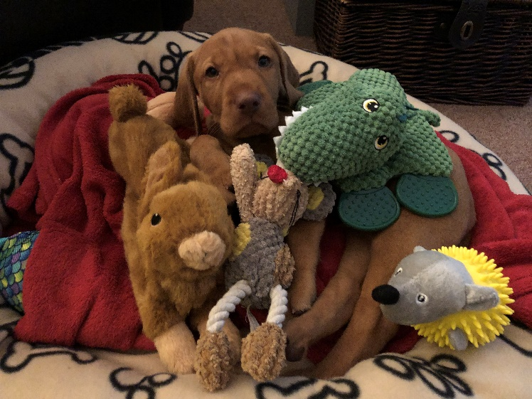
Those words simply don’t convey the cheekiness, the love in his eyes and the sheer joy that he brings to our lives.
Stay with me….I’m promise I am not being heretical and comparing God to Ralf…
Next….a photograph taken of a family wedding……(SLIDE, Wedding Photo)

we see people….we see the clothes they are wearing…..we see their hair styles……..we see how young they look….Jeanette you haven’t changed a bit in the ….???.years we have married.
What it won’t tell us is the complex personalities and the quirky sense of humour of some….and the lack of sense of humour of others…..it wouldn’t tell us who Loves seafood or hates broccoli…and those whose perfect night in is a few cream crackers and a nice bit of stinking bishop….it’s cheese!!
There are all kinds of things that we need to experience personally for us to truly get an understanding of what it means….these abstract definitions or pictures show a very small part of what is a massive and very personal story.
So, if this applied to Dogs and Families…how much more will it be true of anything concerning God and our relationship with God as Father, son and Holy Spirit?
(SLIDE ‘trinity’)
‘’anything we can understand, cannot be God’
Words are inadequate when trying to explain and pin down this elusive mystery….and we SHOULD NOT restrict it to a lifeless form.
Our Gospel reading today offers us vivid word pictures of the love of God which dances between the three persons of God: Father, Son and Holy Spirit and which seeks to draw others into that dance of love and delight….it seeks to draw you and I into that relationship.
Several times in his conversation with Nicodemus, Jesus uses the image of being re-born: “born from above”; “born of water and Spirit”. It’s as if Jesus is trying to get across how completely different life with God is – so different it’s like entering a whole new world. A world that we simply can not expect to fully comprehend.
We’re also reminded that it’s always God who takes the initiative in the salvation of his creation. Jesus compares himself to the bronze serpent which God told Moses to make to heal all who looked up at it. He offers a picture of himself being lifted up to be the focus for healing and the source of eternal life, freely given to all who believe in him…
Who am I that he would offer that sacrifice for me?

So, in essence, I have spent the last 10 minutes explaining that our attempts….and the attempts of these and many more authors to explain and rationalise the Trinity is a fruitless act.
In trying to apply human understanding to the God the Father, the son and the holy spirit, to calculate the sum of the parts, I think, is to miss something profoundly important about the Trinity and about us as human beings. We are created in God’s image. I wonder whether you’ve ever thought about the implications of that. That suggests that there is a certain goodness, in us, no matter how stained that goodness might be by our sins. But more than that, as Christians we believe that God is three-in-one, God by God’s nature in relationship, reaching out beyond Godself, loving in Godself. All that implies that being created in God’s image, we are created to be in relationship as well. This is how we get to the focus of many if not all of my sermons so far in my ministry. Love.

PAUSE

The Holy Trinity in action is like a loving Father, taking the initiative in sending his Son to save a world that may not know it needs saving.
The Holy Trinity in action is like Jesus, Son of God and Son of Man. He shows us what God and love look like in human form and identifies himself with human pain and suffering.
The Holy Trinity in action is the Holy Spirit, bringing new birth, new identity and the invitation to join in the dance of love and delight that is God, Father, Son and Holy Spirit.
The Spirit, through which we receive the gift of eternal life, is not a spirit of fear leading us into captivity. It’s a spirit of adoption, a form of new birth, which draws us into the family of God, Father and Son, so that we too can call God “Abba, Father”. We are loved…..You are Loved…We are children of God.

Amen

